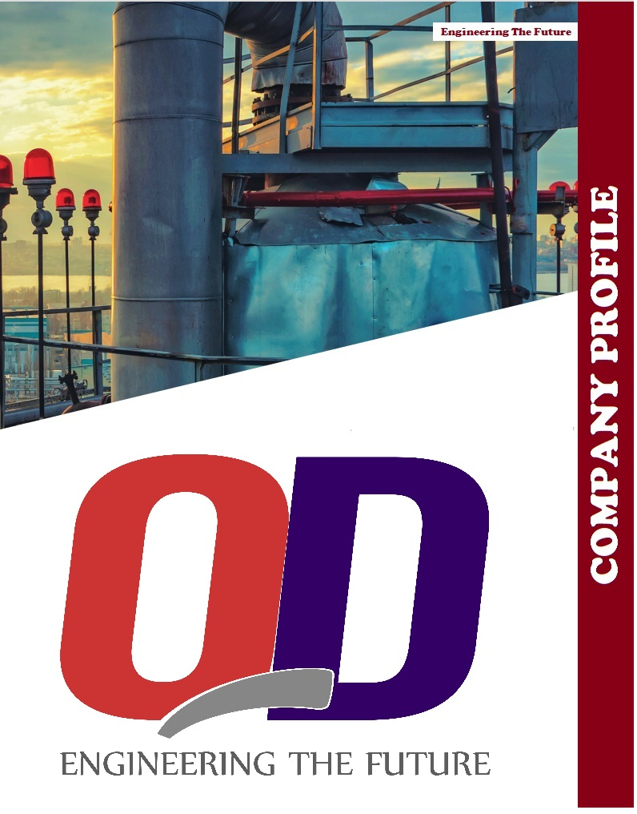


Executive Information...

Brief Introduction

Quantum dynamic’s Target is to be become a world -class construction company with brand as Forerunner management as base. Personnel as core. Renovation as power, mechanism as guarantee, information as breakthrough and culture as guide. QD is proud that with the blessings of almighty Allah, QD is moving fast towards their splendid future with their intelligence, courage and honesty.
(QD) as established since then, the company has become successful and motivated for excellence in oil & chemicals & petro-chemical, power, cement, fertilizer and infrastructure sector.
However, even before the establishment of “QD”, the founders of the company have been involved in equipment installation, Fabrication, Erection of piping network, tanks and Steel structure work activities for the last two decades.
However, even before the establishment of “QD”, the founders of the company have been involved in equipment installation, Fabrication, Erection of piping network, tanks and Steel structure work activities for the last two decades.
QD is a construction company having distinct position in the market and very good relations with the Clients. QD`s main business is to do General Contractor of Mechanical & Civil Works, Equipment Manufacturing. Equipment installation, building construction, cross country pipeline, various manufacturing, installation of construction material, equipment, steel structure, crane without track, manufacturing at in site and local manufacturing of large equipment.
QD has successful experience in Building construction, Equipment installation, erection. Fabrication and welding, etc. QD follows the three “Zeros” concept i.e.
•Zero Injury
•Zero Accident
•Zero life loss

ENGINEERING THE FUTURE...
Executive Information...

And ensures the proper utilization of personal protective equipment’s (PPE’s) so that the encountered risk in construction could be minimized. QD has good relations and cooperation with the owners which is a result of excellent coordination in all aspects such as in civil works, equipment configurations, and realizing the best project investment.
QD’s team of executive and engineers is highly qualified, energetic and having rich experience in construction industry “QD”, is also having a team of over 400 workers as well as technicians who have undergone specialize training in the field of Design. Planning, fabrication, Erection, insulation, Sandblasting and painting etc.
Timely completion of all ongoing projects always received out highest priority. “QD” activities have now also been extended to diversified huge projects of national significance, especially for cement, fiber, chemical, oil refinery and power generation plants with complete technical know -how.
The company is well equipped with modern tools & equipment’s. Moreover, the enterprises tales special pride in its latest quality control facilities to monitor record and maintain the supreme quality standards to the entire satisfaction of our valued clients . Emphasis on quality work at all stages of design. Planning and installation jobs is the hallmark of our organization for which our team enjoys enviable reputation in the public as well as private sector
QD Engineers have very vast experience in the installation of Equipment, Fabrication, Erection, Sand blasting, painting, etc. of many projects.
Fabrication and Erection of MS Storage tanks, Oil Storage tanks, pipe Rack structure piping, pumps, chillers, cooling Towers Waste water treatment plant, gas Turbine 175 MW. Turbine, Diesel Power Generator, generators, firefighting system. Crude oil storage tanks (Floating roof type 62 meter dia 06 Nos.) steel Rib/ Arch, 70 Ton, 40 TPD Boiler “H .T. Boiler Steel Structure for Pre -Heater 750 ton. 263ft, height. Storage shed (135-meter-long and 52 meter wide). Process piping, nitrogen plant piping, utility piping, air handing unit, 08 Nos. cooling water storage tanks, etc.
QD Engineers also have a experience in hydro -testing, pre-commissioning & commissioning activities, shutdown, dismantling, insulation, etc.

ENGINEERING THE FUTURE...

General Information:

- Company Name : Quantum Dynamics (Pvt.) Limited.

- Main Office : Shakir Kot, Airport Road, Sadiqabad,

- PEC Registration No. : Mech/53430

- NTN No. : 3817212-7

- PST No. : P3817212-7

- Incorporation No. : 0077000

- General Sale Tax No. : 32-77-8761-987-47

ENGINEERING THE FUTURE...

Company Organization Structure









CEO
General Manager
Advisor
QHSE Manager
Maintenance
Manager
Operations
Manager
Superintendent
Workshop
Project Manager
Head of IT &Stores
Finance & Admin
Commercial &
Manager
Development
Business
Manager
Project Engineer

ENGINEERING THE FUTURE...

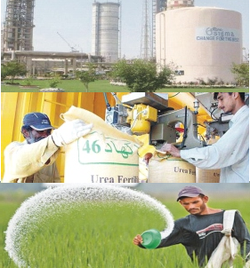
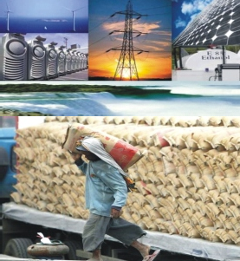
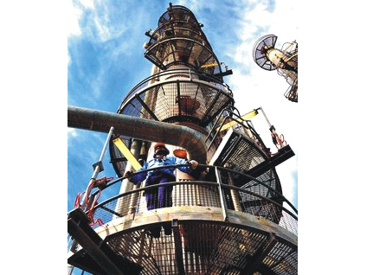


BUSINESS SECTOR

Oil & Gas | Chemical & Petrochemical | Power & Cement | Fertilizer Infrastructure | Food Industries

Trust
CORE VALUES
  - Honesty
  - Integrity
  - Courage
  - Respect and dignity
  - Prosperity for stakeholders including employees
PROJECT MANAGEMENT
QD team has a track record successfully managing projects within the defined scope, budget, quality and safety parameters. Over the years, the management team has been involved in evolving and implementing various projects management and control systems enabling sharp focus on cost and schedule control.

ENGINEERING THE FUTURE...





Our Values...
Candid and open environment
Commitment and team work
OUR VALUES, PURPOSE, VISION & MISSION STATEMENTS

QD team has a track record successfully managing projects within the defined scope, budget, quality and safety parameters. Over the years, the management team has been involved in evolving and implementing various projects management and control systems enabling sharp focus on cost and schedule control.

Professionalism, Ethics and integrity

We believe in professional, honest and ethical behavior in all our activities and that the course of highest integrity will establish and maintain the highest professional and personal standards.

We honor commitments made to our internal and external clients and strive to work effectively as a team we believe that teams containing appropriate diversity of skills and approach can achieve a high level of synergy that individuals alone cannot.

We encourage an environment where all communication is candid, courteous and provide adequate information enabling us to do our jobs more effectively and contribute to the quality of our decision making.

ENGINEERING THE FUTURE...


To become a world-class engineering, manufacturing and construction company, operating nationally.
VISION

To provide our customers with quality, cost effective and reliable solutions as and EPC contractor at home and a manufacturer of plant and equipment in the region.
MISSION
To bring prosperity and wellbeing to our stake holders and society at large by adding value to engineering, technology and management
PURPOSE

EXPERIENCE OF KEY PERSONAL

- FFCL (SCAFFOLDING ANNUAL 3 YEAR PROJECT) MUKHTAR GARH SADIQABAD.
- FFCL ANNUAL SANDBLASTING MUKHTAR GARH SADIQABAD-PAKISTAN
- FFBL SCAFFOLDING ANNUAL PROJECT PORT QASIM KARACHI- PAKISTAN
- FFCL (PURLIN SHEETS PROJECT MUKHTAR GARH SADIQABAD - PAKISTAN
- FFCL (ANNUAL SCAFFOLDING-19 PROJECT MUKHTAR GARH SADIQABAD - PAKISTAN
- FFCL (TA-19 SCAFFOLDING PROJECT MUKHTAR GARH SADIQABAD – PAKISTAN
- FFCL (NP PLANT AGITATORS TA-19 PROJECT MUKHTAR GARH SADIQABAD - PAKISTAN
- FFCL (TA-19 MODIFICATION JOBS MUKHTAR GARH SADIQABAD – PAKISTAN
- FFCL (TA-19 NG DRAINAGE FACILITY MUKHTAR GARH SADIQABAD – PAKISTAN
- FFCL (EXECUTION OF O & U TA_19 MOC’S MUKHTAR GARH SADIQABAD – PAKISTAN
- FFCL (MTM CYCLONES TA-19 JOB MUKHTAR GARH SADIQABAD – PAKISTAN
- FFCL (SUCTION DUCTS TA-19 JOB MUKHTAR GARH SADIQABAD – PAKISTAN
- FFCL (KNOCK OUT DRUM PROJECT MUKHTAR GARH SADIQABAD – PAKISTAN
- FFCL (LCO2 PLANT MUKHTAR GARH SADIQABAD – PAKISTAN
- FPCDL (DOOSAN POWER PLANT DAHARKI – PAKISTAN
- FPCDL (DOOSAN POWER PLANT DAHARKI – PAKISTAN
- FPCDL (DOOSAN POWER PLANT DAHARKI – PAKISTAN
- FPCDL (DOOSAN POWER PLANT DAHARKI – PAKISTAN
- ENGRO - DAHARKI, PAKISTAN
- BHP - ZAMZAMA GAS FIELD DADO, PAKISTAN
- OMV, KADIN WARI- PAKISTAN
- ICI – PAKISTAN
- CHAKWAL CEMENT PROJECT
- D.G CEMENT, CHAKWAL
- DEFENSE HOUSING SCHEME PHASE-2
- OMV PAKISTAN
- BERINI
- OMV PAKISTAN
- FRONTIER WORKS ORGANIZAITON
- NATIONAL DEVELOPMENT COMPLEX
- SHASHI PIPE FACTORY, KARACHI
- ICI POLYESTER PLANT, SHEIKHUPURA
- MAZARI OIL FIELD UPGRADE PROJECT MATLI
- 44 KTPA POLYESTER STAPLE FIBER PROJECT
- ICI SODA ASH WORKS, KHEWRA
- PASTE PLANT, ISLAMABAD
- PAK ARAB REFINERY, PROJECT
- DEWAN SALMAN ACRALIC PLANT, HATTAR
- ATTOCK OIL REFINERY, RAWALPINDI
- ICI SODA ASH WORKS, KHEWRA
- FAUJI CEMENT PLANT, FATEH JUNG
- PAP PLANT NEARFATEHJANG
- HEAVY MECHANICAL COMPLEX TAXILA
- DEWAN SALMAN POLYESTER , HATTAR
- ICI POLYESTER PLANT, SHEIKHUPURA
- ICI POLYESTER PLANT, SHEIKHUPURA
- KHAUR OIL & GAS BATTERY, PAKISTAN OILFIELD, LTD
- DEWAN SALMAN PLOYESTER UNTI #2 HATTAR
- THERMAL POWER STATION, UNIT 05 & 06 MUZAFARGARH
- DEWAN SALMAN PLOYESTER PLANT #.1 HATTAR

Quantum Dynamics Private Limited

CEO | Kaiwan Danish
Main Office | Shakir Kot, Airport Road Sadiqabad, Rahimyarkhan
PEC Registration No | Mech/53430
NTN No | 3817212-7
PST No | P3817212-7
Incorporation No | 0077000
General Sale Tax No | 32-77-8761-987-47
Email Address | kaiwandanish@gmail.com, info@qdl.com.PK shafiqaslamsas@gmail.com, aavais@outlook.com
Website | www.qdl.com.pk
Director | Shafiq Aslam
Tel CEO | 0300-8671833
TEL Directoe | 0300-6796379
TEL Head of (P&C) | 0300-2980098

